MOBILE RECHARGE PLAN COST CALCULATOR
Author: Radha sahithi Challa
1. Problem Statement
Develop a Python program that compares mobile recharge plans according to a user's required call minutes, data usage,
validity period, and budget. For each plan with sufficient validity, the program calculates the cost of extra call minutes and
data, displays the total cost, and selects the lowest-cost plan that stays within the user's budget.
2. Objectives
• Store recharge-plan details using a list of tuples.
• Accept call minutes, data requirement, validity days, and budget from the user.
• Validate input values before calculation.
• Calculate extra call and data charges beyond each plan's free allowance.
• Exclude plans whose validity is too short.
• Identify the lowest-cost eligible plan within budget.
• Display plan costs or explain when no plan meets the requirements.
3. Assumptions
• All prices and usage rates are illustrative values supplied in the program, not current offers from a mobile operator.
• A plan is considered only if its validity is greater than or equal to the required number of days.
• Included call minutes and data are deducted before extra charges are calculated; extra usage cannot be negative.
• Extra call charges are calculated per minute and extra data charges per GB, using the rates in each tuple.
• The plan price is always included in the total cost.
• Inputs are assumed to be numeric in the format requested; conversion errors (such as typing letters instead of a number) are
not caught by this version.
• If two plans have the same cost, the first qualifying plan in the list remains selected.
4. Algorithm
1. START.
2. Store each recharge plan as a tuple in the plans list.
3. Read required call minutes, data in GB, validity days, and budget.
4. If minutes, data, or budget are negative, or days are not positive, print "Invalid input" and STOP.
5. Set best_plan to an empty string and minimum_cost to zero.
6. For each plan, unpack its price, included usage, validity, and extra-use rates.
7. If the plan validity meets the required days:
a. Calculate extra call minutes and extra data, using zero if usage is within allowance.
b. Calculate total cost = plan price + extra call charges + extra data charges.
c. Print the plan's total cost.
d. If total cost is within budget and no cheaper eligible plan has been selected, update best_plan and minimum_cost.
8. If no plan fits the budge

4. Algorithm
1. START.
2. Store each recharge plan as a tuple in the plans list.
3. Read required call minutes, data in GB, validity days, and budget.
4. If minutes, data, or budget are negative, or days are not positive, print "Invalid input" and STOP.
5. Set best_plan to an empty string and minimum_cost to zero.
6. For each plan, unpack its price, included usage, validity, and extra-use rates.
7. If the plan validity meets the required days: a. Calculate extra call minutes and extra data, using zero if usage is within allowance. b. Calculate total cost = plan price + extra call charges + extra data charges. c. Print the plan's total cost. d. If total cost is within budget and no cheaper eligible plan has been selected, update best_plan and minimum_cost.
8. If no plan fits the budget and validity, print "No plan available within budget".
9. Otherwise, print the selected plan and minimum cost.
10. STOP.

5. FLOW CHART
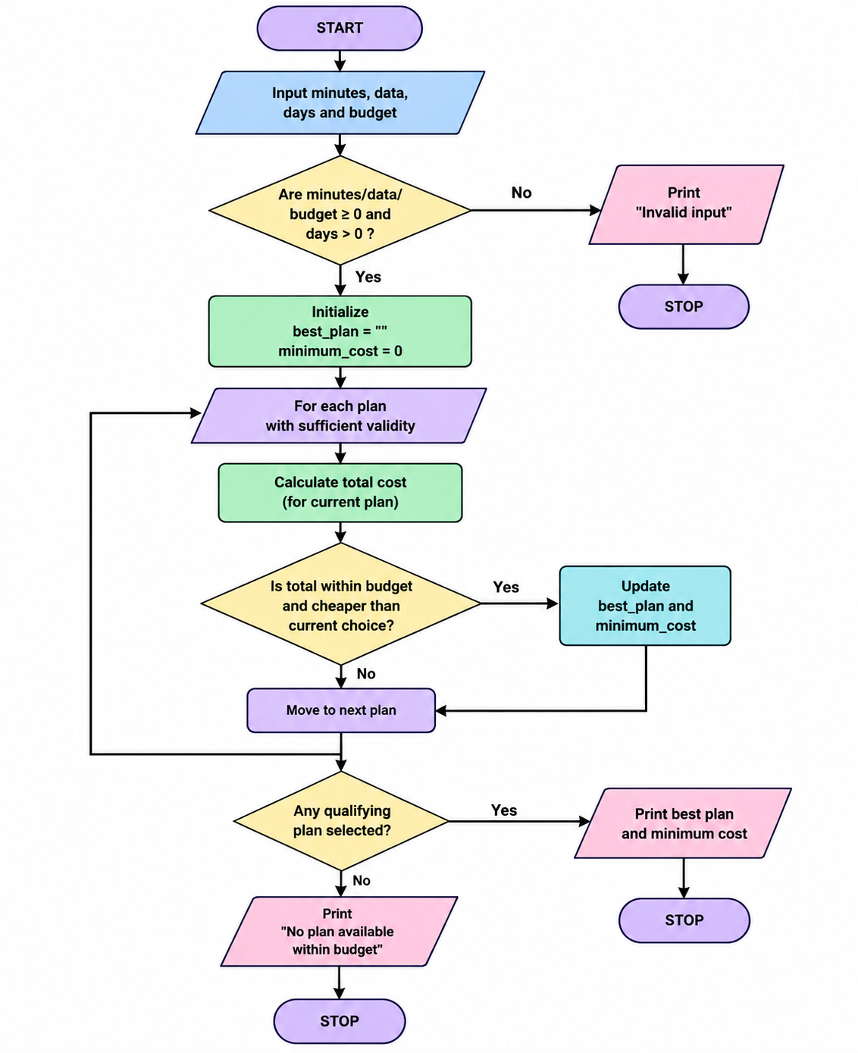

PSEUDO CODE

BEGIN
plans <- list of plan tuples
INPUT minutes, data, days, budget
best_plan <- ""
minimum_cost <- 0
IF minutes < 0 OR data < 0 OR days <= 0 OR budget < 0 THEN
PRINT "Invalid input"
ELSE
FOR EACH plan IN plans
UNPACK plan into name, price, free_minutes,
free_data, validity, call_rate, data_rate
IF validity >= days THEN
extra_calls <- MAX(0, minutes - free_minutes)
extra_data <- MAX(0, data - free_data)
total <- price + extra_calls * call_rate
+ extra_data * data_rate
PRINT name and total cost
IF total <= budget THEN
IF best_plan = "" OR total < minimum_cost THEN
best_plan <- name
minimum_cost <- total
END IF
END IF
END IF
END FOR
IF best_plan = "" THEN
PRINT "No plan available within budget"
ELSE
PRINT best_plan and minimum_cost
END IF
END IF
END

PYTHON CODE

plans = [
("Basic", 199, 300, 2, 28, 1, 20),
("Standard", 399, 600, 5, 28, 0.75, 15),
("Premium", 599, 1000, 10, 56, 0.50, 10)
]
minutes = int(input("Required call minutes: "))
data = float(input("Required data in GB: "))
days = int(input("Required validity in days: "))
budget = float(input("Enter budget: "))
best_plan = ""
minimum_cost = 0
if minutes < 0 or data < 0 or days <= 0 or budget < 0:
print("Invalid input")
else:
for plan in plans:
name, price, free_minutes, free_data, validity, call_rate, data_rate = plan
if validity >= days:
extra_calls = max(0, minutes - free_minutes)
extra_data = max(0, data - free_data)
total = price + extra_calls * call_rate + extra_data * data_rate
print(name, "Total Cost: Rs.", round(total, 2))

if total <= budget:
if best_plan == "" or total < minimum_cost:
best_plan = name
minimum_cost = total
if best_plan == "":
print("No plan available within budget")
else:
print("Best Plan:", best_plan)
print("Minimum Cost: Rs.", round(minimum_cost, 2))

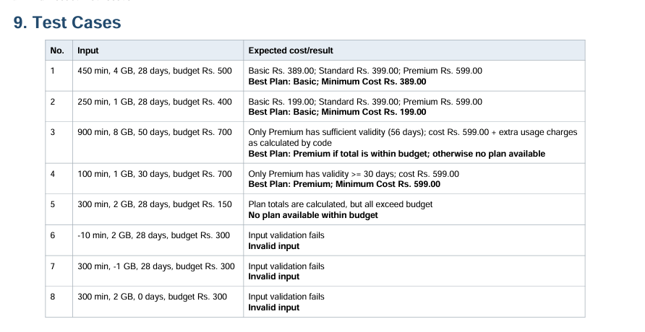

MY OUTPUT

Required call minutes: 30
Required data in GB: 2
Required validity in days: 26
Enter budget: 299
Basic Total Cost: Rs. 199
Standard Total Cost: Rs. 399.0
Premium Total Cost: Rs. 599.0
Best Plan: Basic
Minimum Cost: Rs. 199

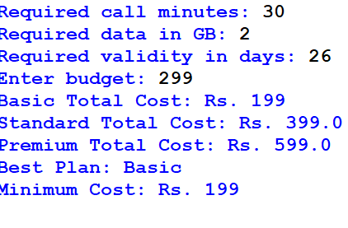

MY COCLUSION
This project demonstrates Python input and output, arithmetic operations, conditional statements, loops, lists, tuples, and minimum-cost selection. It helps a user compare recharge plans against usage needs, validity requirements, and a spending limit. The plan rates are examples and should be replaced with verified operator tariffs if the program is used for real purchasing decision

